WEEK 3 PROJECT REPORT
PROCESS SCHEDULING SIMULATOR
Design and Implementation of CPU Scheduling Algorithms Using C
Project-Based Learning (PBL)
Submitted by:
sinchana— Team Lead
Team Members:
1.Aahil
2.josna
3.jishnu
Technologies Used:
C Programming, GCC, Linux, Make, Git and GitHub
Project Repository:
PBL-kiri
Academic Year:
2026–2027

1. Introduction
Process scheduling is an important function of an operating system. It determines the order in which processes are executed by the CPU. Different scheduling algorithms use different methods to allocate CPU time to processes.
The Process Scheduling Simulator is developed using the C programming language to demonstrate and compare different CPU scheduling algorithms. It accepts process details such as Process ID, Arrival Time, Burst Time, and Priority, and displays the execution order using a Gantt chart.
The simulator calculates performance metrics such as Waiting Time, Turnaround Time, Response Time, and CPU Utilization to help analyze the performance of each algorithm.

2. Objectives
- To implement different CPU scheduling algorithms using C.
- To understand the working of preemptive and non-preemptive scheduling.
- To display process execution using Gantt charts.
- To calculate Waiting Time, Turnaround Time, and Response Time.
- To calculate CPU Utilization.
- To compare the performance of scheduling algorithms using different test cases.

3. Input Specification
The simulator accepts the following details for each process:
Input | Description
Process ID (PID) | Unique identifier assigned to each process
Arrival Time (AT) | Time at which the process enters the ready queue
Burst Time (BT) | Total CPU time required by the process
Priority (PR) | Priority assigned to each process
Time Quantum | Maximum CPU time allocated to a process in one turn of Round Robin scheduling

The user enters the process details, selects a scheduling algorithm, and views the Gantt chart and calculated performance metrics.
4. Performance Metrics and Formulas
1. Completion Time (CT)
The time at which a process finishes execution.
2. Turnaround Time (TAT)
TAT = Completion Time − Arrival Time
3. Waiting Time (WT)
WT = Turnaround Time − Burst Time
4. Response Time (RT)
RT = First CPU Start Time − Arrival Time
5. Average Waiting Time
Average WT = Sum of Waiting Times ÷ Number of Processes
6. Average Turnaround Time
Average TAT = Sum of Turnaround Times ÷ Number of Processes
7. CPU Utilization
CPU Utilization = (CPU Busy Time ÷ Total Elapsed Time) × 100%

5. Scheduling Algorithms
The Process Scheduling Simulator implements six CPU scheduling algorithms. Each algorithm follows a different method to select processes for CPU execution.
5.1 First Come First Serve (FCFS)
FCFS is a non-preemptive scheduling algorithm in which processes are executed in the order they arrive in the ready queue. Once a process starts execution, it continues until completion.
5.2 Shortest Job First (SJF) — Non-Preemptive
SJF Non-Preemptive selects the available process with the shortest burst time. Once selected, the process executes until it finishes.
5.3 Shortest Remaining Time First (SRTF) — Preemptive
SRTF is the preemptive version of SJF. The CPU executes the process with the shortest remaining burst time. If a process with a shorter remaining time arrives, the currently running process may be interrupted.
5.4 Priority Scheduling — Non-Preemptive
Priority Non-Preemptive selects the available process with the highest priority. Once execution begins, the process continues until completion.
5.5 Priority Scheduling — Preemptive
Priority Preemptive selects the process with the highest priority. If a higher-priority process arrives, it can interrupt the currently running process.
5.6 Round Robin (RR)
Round Robin assigns each process a fixed time slice called the time quantum. If a process does not finish within its allocated time, it returns to the ready queue to wait for another turn.

6. Test Case 1 — Process Scheduling
6.1 Input Details
The first test case is used to evaluate the behavior of the CPU scheduling algorithms using four processes with different arrival times, burst times, and priorities.
Process ID | Arrival Time (AT) | Burst Time (BT) | Priority (PR)
P1 | 0 | 7 | 2
P2 | 2 | 4 | 1
P3 | 4 | 1 | 3
P4 | 5 | 2 | 2
The same input values are used for all six scheduling algorithms so that their performance can be compared fairly.
Test Case 1
6.1 First Come First Serve (FCFS) Scheduling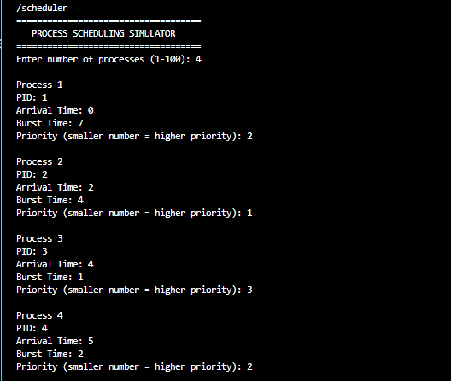

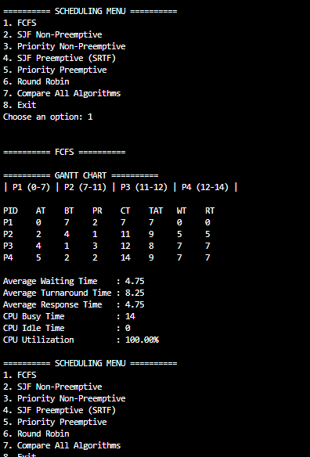

Figure 1: FCFS Scheduling Output for Test Case 1

5.2 Shortest Job First (SJF) — Non-Preemptive
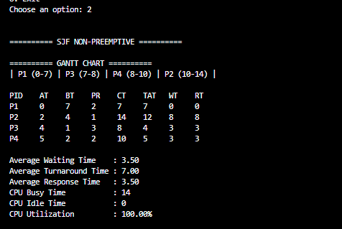
Figure 2: SJF Non-Preemptive Scheduling Output for Test Case 1.

5.3 Priority Non-Preemptive Scheduling
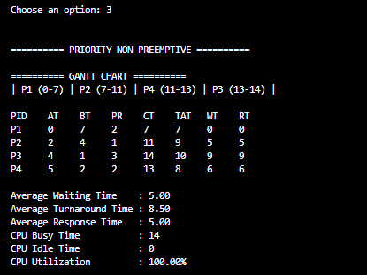
Figure 3: Priority Non-Preemptive Scheduling Output for Test Case 1

5.4 SJF Preemptive (SRTF)
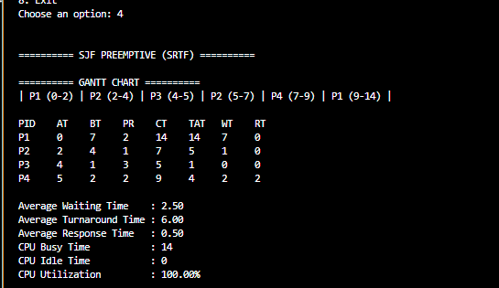
Figure 4: SJF Preemptive (SRTF) Scheduling Output for Test Case 1.

5.5 Priority Preemptive Scheduling
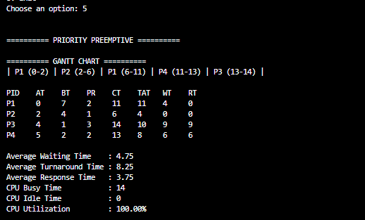
Figure 5: Priority Preemptive Scheduling Output for Test Case 1.

5.6 Round Robin Scheduling
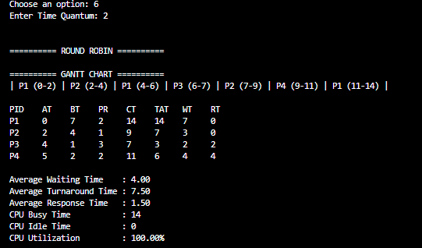
Figure 6: Round Robin Scheduling Output for Test Case 1.

Compare All Algorithms
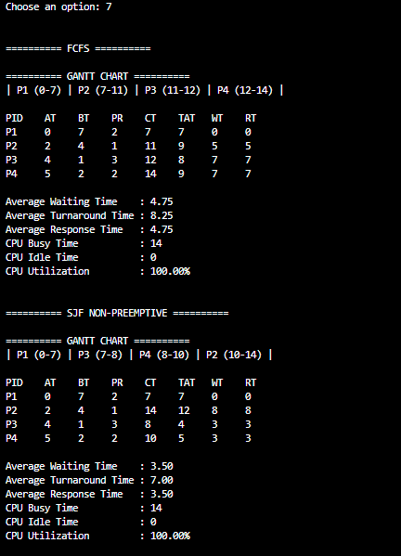
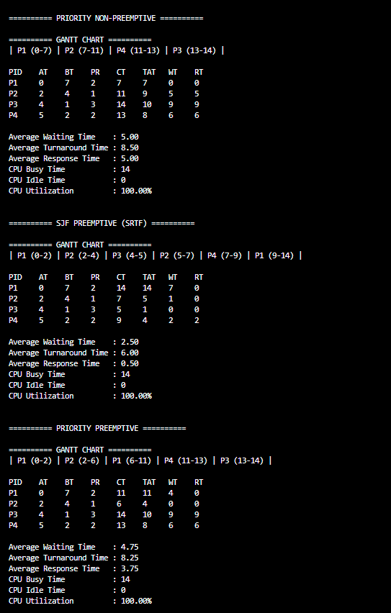

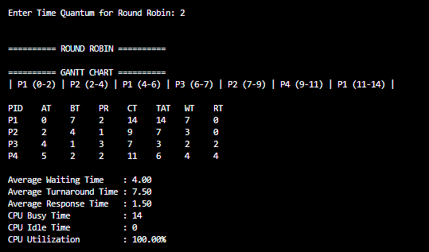

Figure 7: Comparison of CPU Scheduling Algorithms for Test Case 1.

TEST CASE 2
Test Case 2 — Process Inputs
PID | Arrival Time | Burst Time | Priority
P1 | 0 | 3 | 3
P2 | 1 | 6 | 1
P3 | 2 | 2 | 4
P4 | 4 | 4 | 2
5.7 Test Case 2 — FCFS Scheduling

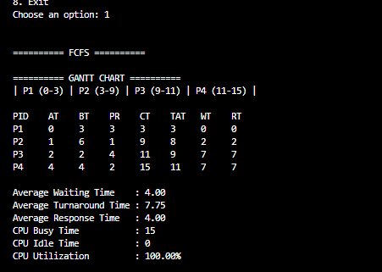
Figure 8: FCFS Scheduling Output for Test Case 2.

Test Case 2 — SJF Non-Preemptive Scheduling
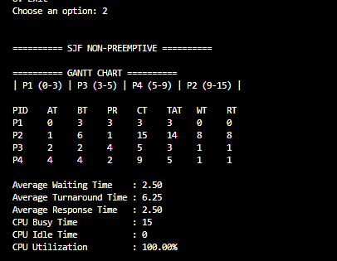
Figure 9: SJF Non-Preemptive Scheduling Output for Test Case 2.

Test Case 2 — Priority Non-Preemptive Scheduling
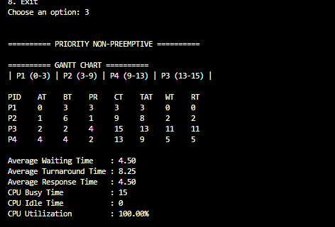
Figure 10: Priority Non-Preemptive Scheduling Output for Test Case 2.

Test Case 2 — SJF Preemptive (SRTF) Scheduling

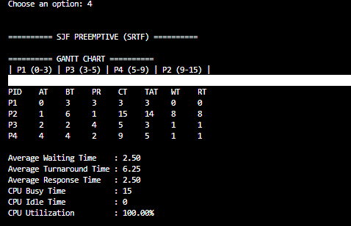
Figure 11: SJF Preemptive (SRTF) Scheduling Output for Test Case 2.

Test Case 2 — Priority Preemptive Scheduling
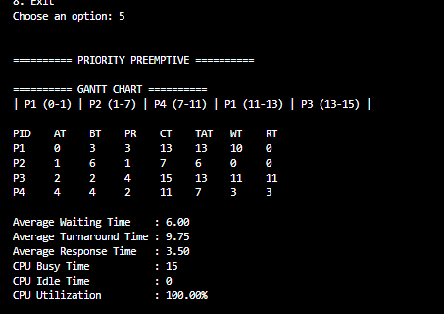
Figure 12: Priority Preemptive Scheduling Output for Test Case 2.

Test Case 2 — Round Robin Scheduling
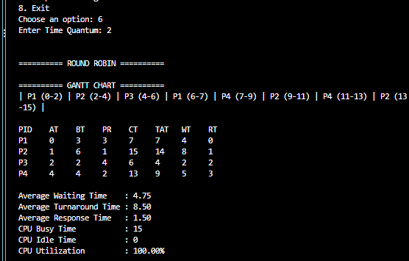
Figure 13: Round Robin Scheduling Output for Test Case 2.

Test Case 2 — Overall Algorithm ComparisoN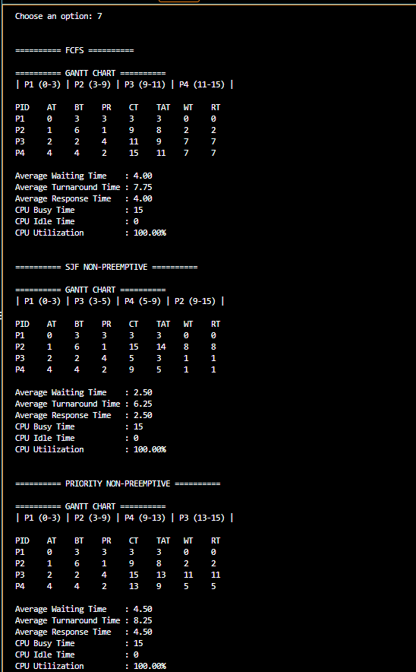

N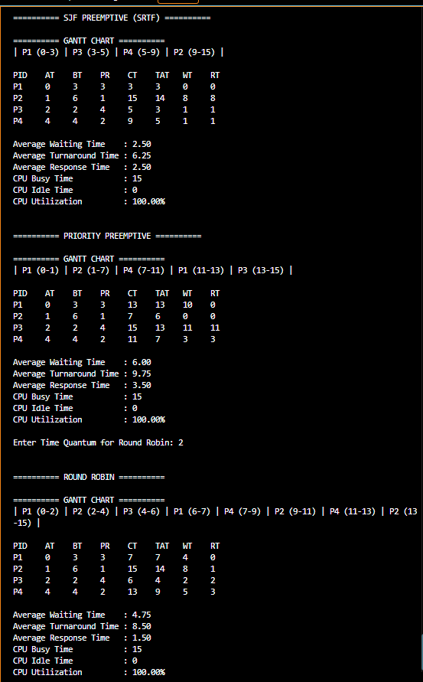
Figure 14: Overall Scheduling Algorithm Comparison for Test Case 2.

Test Case 3 — Process Scheduling Simulation
Input Details
Process ID | Arrival Time | Burst Time | Priority
P1 | 0 | 5 | 2
P2 | 1 | 3 | 3
P3 | 3 | 6 | 1
P4 | 5 | 2 | 4
Round Robin Time Quantum: 2

1. FCFS (First Come, First Served)

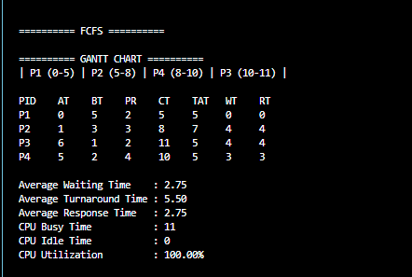
Figure 3.1 FCFS Gantt Chart — Test Case 3

2. SJF Non-Preemptive
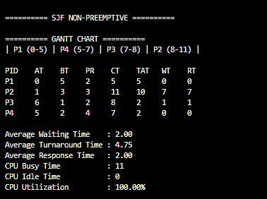
Figure 3.2 SJF Non-Preemptive Gantt Chart — Test Case 3

3. Priority Non-Preemptive Scheduling

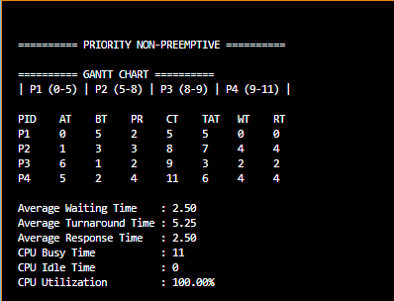
Figure 3.3 Priority Non-Preemptive Gantt Chart — Test Case 3

4. SJF Preemptive (Shortest Remaining Time First — SRTF)
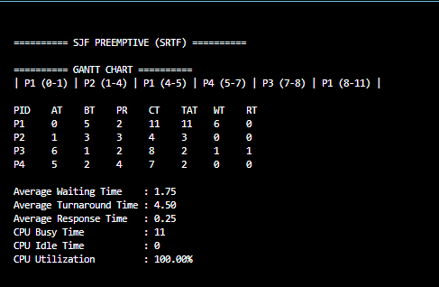
Figure 3.4 SJF Preemptive (SRTF) Gantt Chart — Test Case 3

5. Priority Preemptive Scheduling
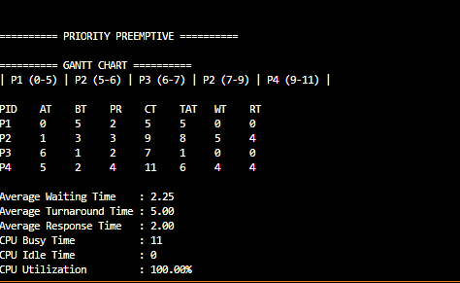
Figure 3.5 Priority Preemptive Gantt Chart — Test Case 3

6. Round Robin Scheduling
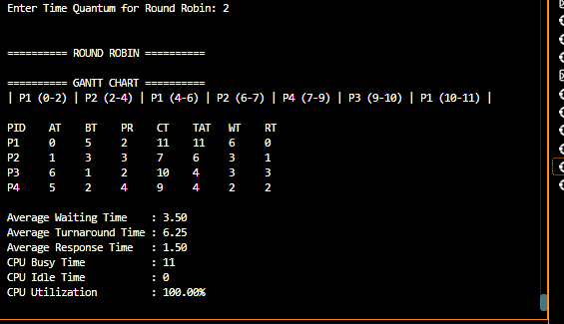
Figure 3.6 Round Robin Gantt Chart — Test Case 3

7. Test Case 3 — Algorithm ComparisoN 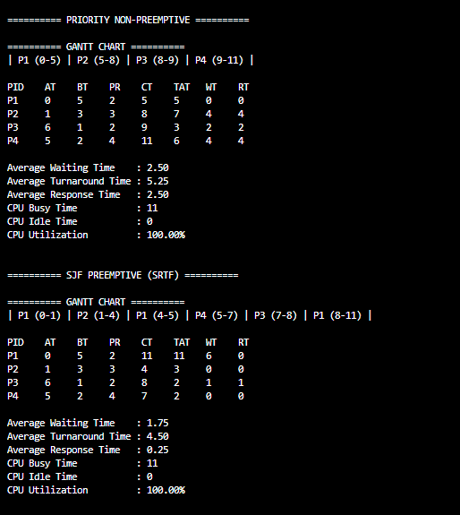 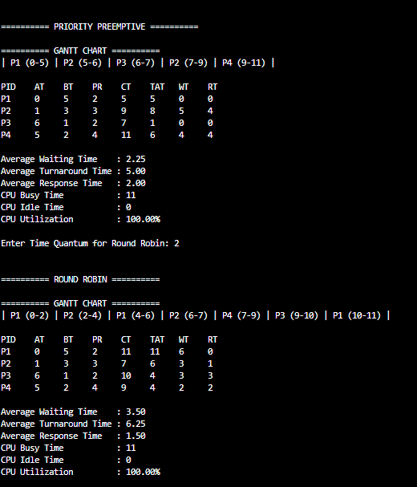

1. Overall Performance Comparison
The six CPU scheduling algorithms were compared using Average Waiting Time, Average Turnaround Time, Average Response Time, and CPU Utilization. The comparison was performed using Test Case 3 with four processes and a Round Robin time quantum of 2.
Scheduling Algorithm | Avg. Waiting Time | Avg. Turnaround Time | Avg. Response Time | CPU Utilization
FCFS | 2.75 | 5.50 | 2.75 | 100%
SJF Non-Preemptive | 2.00 | 4.75 | 2.00 | 100%
Priority Non-Preemptive | 2.50 | 5.25 | 2.50 | 100%
SJF Preemptive (SRTF) | 1.75 | 4.50 | 0.25 | 100%
Priority Preemptive | 2.25 | 5.00 | 2.00 | 100%
Round Robin (Q = 2) | 3.50 | 6.25 | 1.50 | 100%
The results show that SJF Preemptive (SRTF) achieved the lowest average waiting time, turnaround time, and response time for this test case. Round Robin had the highest average waiting and turnaround times among the six algorithms. All algorithms achieved 100% CPU utilization for this workload because the CPU had no idle intervals.

Performance Analysis
The performance analysis shows that different CPU scheduling algorithms produce different results depending on process arrival times, burst times, and priorities.
FCFS schedules processes in the order they arrive and is simple to implement, but shorter processes may wait behind longer processes. SJF Non-Preemptive reduces waiting time by selecting the shortest available process, while Priority Non-Preemptive selects processes according to priority.
SJF Preemptive, also known as Shortest Remaining Time First (SRTF), achieved the best overall average metrics in Test Case 3 because it can interrupt a running process when a process with a shorter remaining burst time becomes available. Priority Preemptive can also interrupt a running process when a higher-priority process arrives.
Round Robin gives each ready process a fixed time quantum, allowing processes to share CPU time. Its performance depends on the selected quantum. In this test case, a quantum of 2 produced a higher average waiting time and turnaround time than the other algorithms.
CPU utilization was 100% for all six algorithms in this test case. This result applies to the tested workload and does not mean that every algorithm will achieve 100% utilization for every possible input.

Conclusion
The Process Scheduling Simulator was implemented in C to demonstrate and compare six CPU scheduling algorithms: FCFS, SJF Non-Preemptive, Priority Non-Preemptive, SJF Preemptive (SRTF), Priority Preemptive, and Round Robin.
The simulator accepts process details such as PID, arrival time, burst time, and priority, along with a time quantum for Round Robin. It displays Gantt charts and calculates completion time, turnaround time, waiting time, response time, average performance metrics, and CPU utilization.
The test results demonstrate that no single scheduling algorithm is best for every situation. In Test Case 3, SJF Preemptive achieved the lowest average waiting, turnaround, and response times. The project helped us understand how scheduling policies affect process execution and system performance.
Overall, this project provides a practical understanding of CPU scheduling and demonstrates how scheduling algorithms can be evaluated using performance metrics.

